C.E.L.E.U.S.

Ceres Experimental Long Engagement Unit System

**Project Manager:** Sean MacBride

**Project Scientist:** Jamel Miller

**Mission Architect:** Kathryn Goodale

**Lead Engineer:** Amanda McNeil

**Executive Summary:**

With the recent reports on Enceladus and Europa, it has become increasingly likely that there are other places in the Universe and even our solar system that can harbor life. The prospect of a close body supporting life has become much more viable due to scientific advances in miniaturization, instrumentation, and remote analysis. All of these things combine to make an astrobiological survey of Ceres viable and necessary.[1]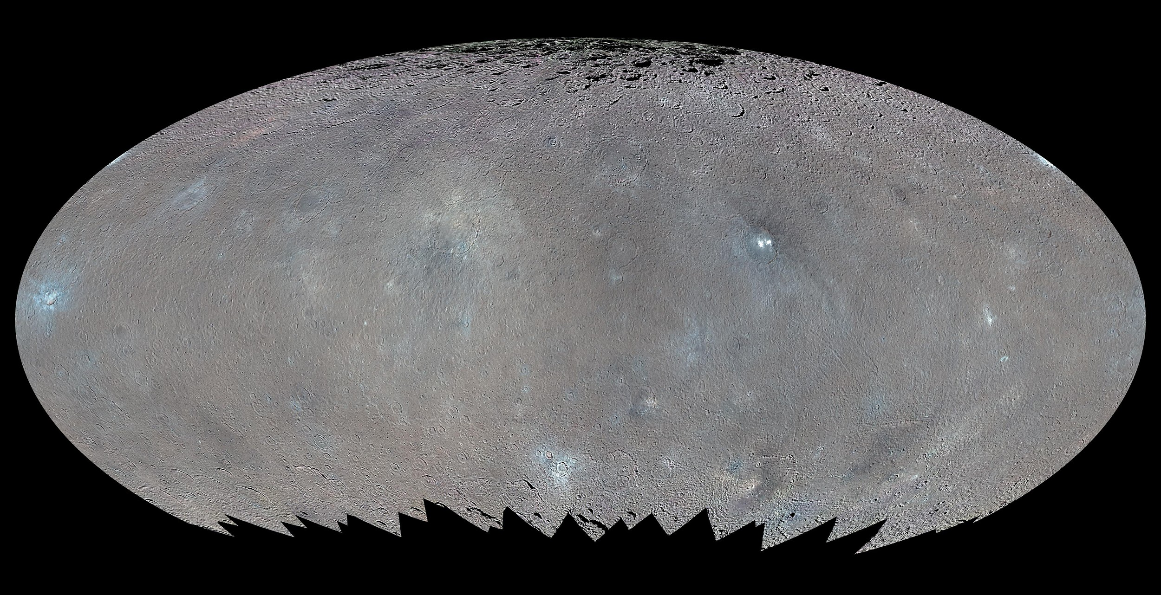

In this mission, Ceres will be explored extensively and thoroughly using a lander and its scientific tools. Ceres will be examined for the presence of organic compounds, as well the possibility of heat flowing from the center of Ceres.[2] Coupling this with the previous knowledge of ice on Ceres surface provides a plausible prospect of life in the future when the sun begins to consume helium and become a red giant.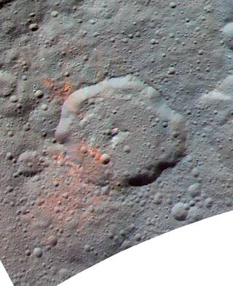

**Scientific Background:**

Being more than 2 astronomical units away at 1.496x108 km, Ceres is the only dwarf planet in the inner solar system. Located in the asteroid belt between Jupiter and Mars, Ceres is the largest discovered by Giuseppe Piazzi in 1801. For a majority of the time that we have known about Ceres, it has been classified it as a asteroid. however in comparison to the other asteroids Ceres comprises of 25% of the total mass of the asteroid belt and is so different from its neighbors. Therefore in 2006 it began to be classified as a dwarf planet.  
 Since its evolution to dwarf planet we have slowly gained new information about this large body, but not nearly as we should. Ceres has a 9 hour day, and one year on this dwarf  
 planet is equivalent to 4.6 earth years. In addition to this, Ceres axis of rotation tilted 4 degrees verse Earth's 23.5 degree. In turn Ceres doesn't experience seasons. However massive in comparison to the other asteroids Ceres is, it’s only 476 km in radius. When compared to Pluto, Ceres is 1/14 the size. For a more relatable size scale in Figure 1, Ceres is not much larger than the State of Texas.[3]  
 From observations, we estimate that Ceres formed 4.5 billion years ago with the rest of the solar system. It is believed that being that Ceres is located in between two large bodies, Mars & Jupiter, those planets pulled a lot more mass toward them not leaving much of Ceres to build from, an “embryonic planet”. However, unlucky, this potential plant was in the past, 2007 marked the year we launched Dawn, which in 2015 became the first spacecraft to orbit a dwarf planet.   
 Dawn has helped answer a lot of questions we previously had, however they just got replaced. With Dawn in orbit, scientist have detected organic compounds, carbon containing, using Visible and InfraRed. It has speculated that these organics are most likely native to Ceres, since it's a dwarf planet it may still have internal heat giving rise to a subsurface ocean. This subsurface ocean is seeming more possible because Dawn found bright spots on crater floors that have been identified as ice volcanos. Previous studies of Ceres have found salts and ammonia on the surface of the dwarf plant. Data taken with data shows the organic compound concentrations at Ceres’ Ernutet crater.[4] The warmer colors indicate higher concentrations.Text Box: Figure 1: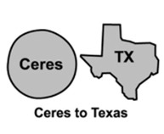

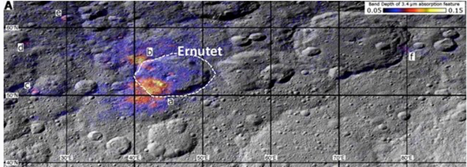

This is noteworthy not only for the general reason of finding organics but, also because Dawn only surveyed the middle latitudes, between 60 degrees north and 60 degrees south.   
 The Dawn spacecraft was a good first step, we identified exciting new hopes for life on Ceres in the form of organics and a subsurface ocean. However, Dawn does have its limitations, the first being it has a limited viewing angle of the body, between 60 degrees north and 60 degrees south. As well as Dawn’s measurements not being precise enough to distinguish what the new organics found are. Therefore a new, better equipped mission to Ceres could potentially end the search for life outside of earth.

**Mission Goals:**

Our main goal for this mission are simple: determine if there is the possibility for life on Ceres. Using a rover equipped with state of the art technology we hope to determine the composition of Ceres surface and the abundance of certain organic materials and compounds. This will be accomplished through a GC/MS and Organic molecule detector. Using the Rover’s seismometer, small explosives will be detonated far away from it to determine the interior structure of Ceres as a whole.

|  |  |  |
| --- | --- | --- |
| **TYPE OF GOAL** | **GOAL** | **DECADAL SURVEY  PRIORITY QUESTION** |
| BASELINE (Assuming no transportation upon landing) | Image the surface of Ceres using a wide angle Camera | 1. What were the initial stages, conditions, and processes of solar system formation and the nature of interstellar matter that was incorporated?   3. What governed the accretion, supply of water, chemistry, and internal differentiation of the inner planets and the evolution of their atmosphere, and what roles did bombardment by large projectiles play?  6. Beyond Earth, are there modern habitats elsewhere in the solar system with necessary conditions, organic matter, water, energy, and nutrients to sustain life, and do organism live there now?  10. How have the myriad chemical and physical processes that shaped the solar system operated , interacted, and evolved over time? |
| Use surface GPR to get a cross section of the structure of Ceres | 1.  3.  4. What were the primordial sources of organic matter, and where does organic synthesis continue today?  6.  9. Can understanding the roles of physics, chemistry, geology, and dynamics in driving planetary atmospheres lead to a better understanding of climate change on earth?  10. |
| LEVEL 1 GOALS | Determine the composition and abundance of materials on Ceres surface | 1.  3.  4.  6.  9.  10. |
| Determine the tectonic activity of Ceres |
| Identify any organic compounds on the surface of Ceres |

**Instrumentation and Datasets:**

Level 1 Science Goals  
 1. Determine the composition of Ceres surface, and the abundance of materials.  
 2. Determine the tectonic activity of Ceres.  
 3. Look for potential organic compounds.

In order to achieve our first level one goal, we aim to have the rover make it to the surface of Ceres and it will be able to perform a variety of different instrumentations. On the rover will be able to drive around to test different site on Ceres for a range of different samples. In addition it will have a drill sampler in-order to get subsurface samples and use the robotic arm to put the sample into the instrumentation.

Paired with surface analysis we aim to our seismometer to analyze the subsurface of Ceres as a second level one goal. With the ice volcanos being visible from Dawn, it is a high possibility that there is water under the surface. However, if the the seismometer doesn't work we could use the Ground Penetrating Radar on the lander to analyze the subsurface as the rover moves across the surface.

Finally, in order to complete our last level one goal we hope to be able to catch any organic compounds on the rover’s GC/MS. In addition to this, we have a organic molecule detector on the lander to identify these compounds.

**Traceability Matrix:**

|  |  |  |  |
| --- | --- | --- | --- |
| **Level 1 Goals** | **Measurement** | **Instrument** | **Sampling** |
| Determine the composition of Ceres surface, and the abundance of materials. | 1. The abundance of different elements.  2. Spectra of different samples | 1. GC/MS  2. Organic Molecule detector | 1. Sampling for GC/MS  2. Drill core sampler |
| Determine the geologic structure of Ceres | 1. Analyze waves bouncing off of the interior layers of the dwarf planet | 1. Seismometer  2. Ground-Penetrating- Radar  3. Heat flow probe | 1. Seismometer will be used to detect tectonic activity 2. GPR used to scan subsurface of Ceres 3. Heat flow probe to determine if head is flowing from inside Ceres |
| Look for potential organic compounds. | 1. The identification of organics. | 1. Organic molecule detector. | 1. organics analyzed on the ground by the lander made with Drill core sampler. |

**Mission Architecture:**

For an Earth to Ceres transfer, including orbit entry into Ceres, the rocket will need 11.78902 km/s of total delta V for all maneuvers. This includes getting off of Earth and getting into an orbit 10 km off of the surface of the asteroid. To accomplish this, a gravity assist around the Earth will be performed. This will allow the rocket to gain the pulling delta V from earth and use less rocket fuel overall. First, the rocket will get off of Earth’s surface into a LEO, then it will perform a burn of 5.151 km/s to get it into an elliptical orbit around the sun that will take two years. Because of its starting point, the rocket will pass by the Earth after two years and gain enough velocity to leave the orbit around the sun; it will gain 6.894 km/s from the close encounter with the Earth. This will bring the rockets total delta V up to 12.0453 km/s as it goes toward Ceres. Once it gets to Ceres, it will need to retro burn to slow down to 11.78902 km/s, so it will need to lose 0.25628 km/s of its delta V, using a monopropellant rocket; this is needed to enter Ceres going 0.497920 km/s because this will be the speed needed to orbit at 10 km above the surface. This will take 57.2350 kg of fuel to accomplish. With a payload of 701.708 kg and a hyperbolic excess velocity of 5.151 km/s, the rocket has a C3 parameter of 26.53589169. This lends best to a Falcon 9 rocket, costing 62 million.

The two orbital maneuvers previously described will put the payload into a 10 km orbit around Ceres. Then, once in orbit, the rover will be deployed and fall toward the planet at 73.4847 m/s. To counteract this, a smaller, monopropellant rocket on the rover container will burn and slow down the container to zero m/s, allowing the rover to safely land on the surface. This small rocket will require 4.9097kg of fuel to slow the rover down to zero.

Calculations:

Orbital Radius of Earth= 149,600,000 km

Orbital Radius of Ceres= 414,000,000 km

Orbital period of Earth= 145,100,000 s

Orbital Period of Ceres= 31,600,000 s

Mass of Ceres= 8.958e20 kg

Mass of Earth= 5.972e24 kg

Gravity of Ceres= 0.27 m/2^2

Finding a for when T is two years:

(((6.307e7)^2*6.67e-11*1.989 × 10^30)/(4pi^2))^(1/3)= 2.37328e11 meters

Finding out delta V for elliptical orbit needed at T= two years:

(2pi(2.37328 × 10^11)/6.307e7)sqrt((2*2.37328 × 10^11/1.496e11)-1)= 34851.3 m/s

34851.3-29700= 5.1513 km/s

Finding delta V gained from earth fly by:

v= sqrt(6.67e-11*5.97e24/(6378100+2000000))= 6894.1 km/s

Total delta V gained:

6.8941+5.1515 km/s= 12.0453 km/s

Velocity needed to be 10 km above Ceres

sqrt((2*6.67e-11*8.958e20)/482000))= 0.497920 km/s

Total delta V needed:

2pi*149600000/31600000= 29.7457 km/s, Earth’s velocity

2pi*414000000/145100000= 17.9272 km/s, Ceres velocity

At= (149600000+414000000)/2= 281800000 km

Pt= sqrt((4pi^2*281800000000^3)/(6.67e-11*1.989e30))= 8.16039e7 seconds

Vp= (2pi*281800000/8.16039 × 10^7)*sqrt((2*281800000/149600000)-1)= 36.104 km/s

Delta V1= 29.7-36.104= 6.404 km/s

Va= (2pi*281800000/8.16039 × 10^7)*sqrt((2*281800000/414000000)-1)= 13.0429

Delta V2= 17.93-13.0429= 4.8871 km/s

Total Delta V= 6.404 km/s + 4.8871 km/s + 0.497920 km/s= 11.78902 km/s

Slowing down 0.25628 to get into orbit:

256.28= 2300ln((468.264+3+1.25f)/(468.264+3+0.25f)), f= fuel needed

Fuel= 57.2350 kg

Going from 10 km up to landing:

Delta V= sqrt((2)(.27)(10000))= 73.4847 m/s

73.4847= 2300ln((147+3+1.25f)/(147+3+0.25f)), f= fuel needed

Fuel= 4.9097 kg

**Timeline of Mission Events:**

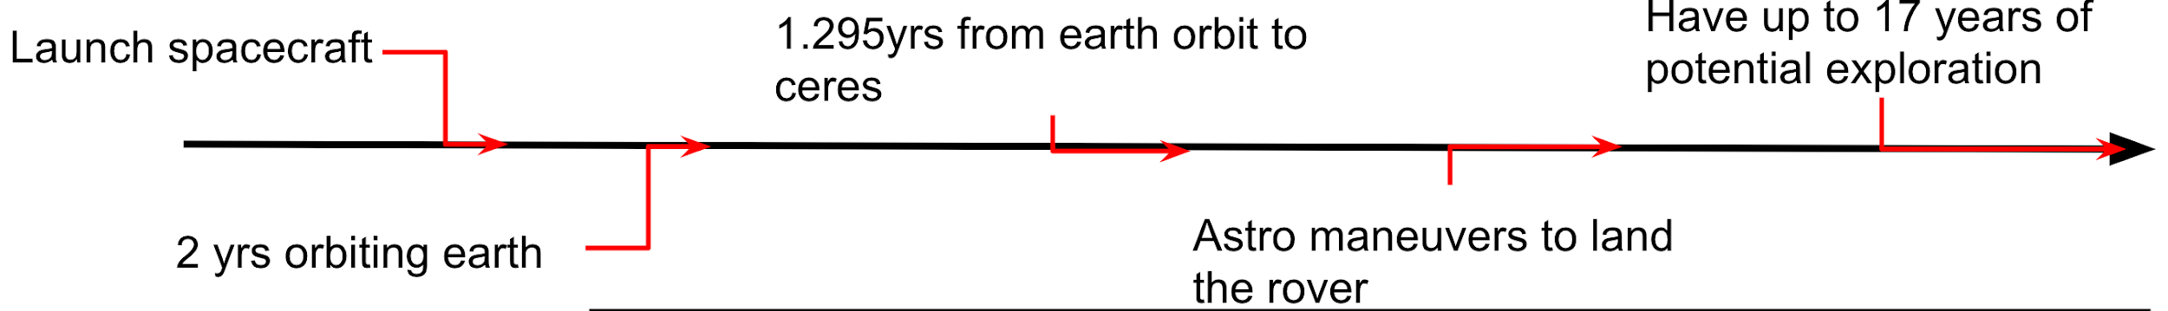

**Operation Modes:**

There are four modes in which the spacecraft will operate, science mode, drilling mode, observation mode, and hibernation mode. Science mode activates the command and data system, the scan platform for the rover, the surface GPR, the seismometer, the heat flow probe, the orbiter’s gas chromatograph and mass spectrometer, the rover’s organic molecule detectors, and the rover’s dish antenna. Drilling mode activates the command and data system, the wide-angle camera, the scan platform for the rover, the drill core sampler, the robotic arm, and the rover’s dish antenna. Observation mode activates the command and data system, the wide-angle camera, the scan platform for the rover, and the rover’s dish antenna. All the mission’s power will be provided by the on-board MMRTG. Hibernation mode only uses the command and Data system of the rover.

Power is most spent through science mode at 100 W of energy, 90 W for drilling mode, and 87 W for observation mode. The data rate for science mode is 6,513,000 bits per second, then 960,600,000 bits per second for drilling mode, and 4,960,200,000 bits per second for observation mode.

In addition to these three operational modes, a fourth mode called hibernation mode will be used to conserve power over the deep space travel part of the mission.

**Concept of Operations:**

Science mode is used to collect and analyze data from Ceres using the rover to see if the asteroid has elements needed to sustain life. This will help us accomplish our goals “Determine the composition of Ceres surface, and the abundance of materials,” “Determine the tectonic activity of Ceres” and “Look for potential organic compounds.” Drilling mode is used to collect data from Ceres using the rover by drilling into the planet to collect samples from underneath the surface of the asteroid. This will help us accomplish our goals “Determine the composition of Ceres surface, and the abundance of materials,” “Determine the tectonic activity of Ceres” and “Look for potential organic compounds.” Observation mode is used to collect data from Ceres using the rover to see where we are and what would be a good place to analyze samples from next. This will help us accomplish our goal of “Look for potential organic compounds.”

**Spacecraft Design and Budget:**

**See attached spreadsheet**

**Risk Management:**

When assessing risks for this mission, the two most obvious involved the entry and landing onto Ceres.

Ceres is a low gravity object has gravity of 0.27 ms-2 or roughly 36 times less than the gravity on earth. This poses a problem both for Ceres capture and Ceres landing. Ceres capture involves an incredible amount of delta v, and the possibility looms of missing Ceres due to too little of a burn. In the event that we were to overburn, it would not be cataclysmic, it would just begin the landing sequence earlier than expected.

The landing sequence itself is the second point of concern. With a low gravity body like Ceres, landing and staying on it would be a massive problem. We have two ways to combat this. With our retro rocket, we can ensure that the delta v for falling onto Ceres will be a gradual enough decrease that the speed at which the orbiter is falling onto Ceres will be safe enough to land. In addition to this, the rover's wheels will be equipped with a suspension that will disperse any impact of force over a longer period of time to decrease the overall impulse of the spacecraft during the impact.

The drill is integral to the success of the mission. Our drill is modeled off a beefier version of the RANCOR drill currently being used on Mars. Given the success rate of the RANCOR drill, it should not be a massive risk to the scientific goals of the mission. In the unlikely event it does fail, we still will be able to accomplish the science goals of “determine the geologic structure of Ceres” and “look for potential organic compounds.”

Data transfer raised minor concerns. With our current setup, it is possible to transmit all of our data with 1.44106 bits per second of a margin before the MMRTG drops in power after 14 years. After the MMRTG drops in power output to 100W, it will only leave a data margin of 3.33104 bits per second. This is accounting for background noise of space and theoretical vs. actual data rates. While 3.33104 bits per second leaves a steady cushion for data, this is assuming no structural damage to the antenna on the spacecraft. If it were to be damaged through either takeoff, landing, or operation on Ceres, it could pose problems for the data transfer.

**CITATIONS**

"Ceres - In Depth | Planets - NASA Solar System Exploration." NASA. Accessed May 04, 2017. https://solarsystem.nasa.gov/planets/Ceres/indepth.

Greicius, Tony. "Dawn Discovers Evidence for Organic Material on Ceres." NASA. February 16, 2017. Accessed May 04, 2017. https://www.nasa.gov/feature/jpl/dawn-discovers-evidence-for-organic-material-on-ceres.

"Map of Ceres." Digital image. Commons.wikimedia.org. March 22, 2016. Accessed May 4, 2017. https://commons.wikimedia.org/wiki/File:PIA20351-Ceres-DwarfPlanet-EllipticalMap-HAMO-20160322.jpg.

Writer, Mike Wall Space.com Senior. "Life's Building Blocks Found on Dwarf Planet Ceres." Space.com. February 17, 2017. Accessed May 04, 2017. http://www.space.com/35729-dwarf-planet-ceres-organic-molecules.html.

1. "Map of Ceres." Digital image. Commons.wikimedia.org. March 22, 2016. Accessed May 4, 2017. https://commons.wikimedia.org/wiki/File:PIA20351-Ceres-DwarfPlanet-EllipticalMap-HAMO-20160322.jpg
2. Greicius, Tony. "Dawn Discovers Evidence for Organic Material on Ceres." NASA. February 16, 2017. Accessed May 04, 2017. https://www.nasa.gov/feature/jpl/dawn-discovers-evidence-for-organic-material-on-ceres.
3. "Ceres - In Depth | Planets - NASA Solar System Exploration." NASA. Accessed May 04, 2017. https://solarsystem.nasa.gov/planets/Ceres/indepth.
4. Writer, Mike Wall Space.com Senior. "Life's Building Blocks Found on Dwarf Planet Ceres." Space.com. February 17, 2017. Accessed May 04, 2017. http://www.space.com/35729-dwarf-planet-ceres-organic-molecules.html.